PHY1010 Readings & Assignments: Week 1
Week 1 Reading
Complete the following reading early in the week:
- Week 1 online lectures
From the assigned textbook Physics, read:
- Introduction to Physics
  - Units of Length, Mass, and Time
  - Dimensional Analysis
  - Converting Units
- Vectors in Physics
  - Scalars Versus Vectors
  - The Components of a Vector
  - Adding and Subtracting Vectors
  - Unit Vectors
  - Position, Displacement, Velocity, and Acceleration Vectors
- Topics 'Essentials of the SI' and 'Background' from the Web site http://physics.nist.gov/cuu/Units/index.html
- Topic 'One-Dimensional motion' from the Web site http://www.batesville.k12.in.us/Physics/PhyNet/Mechanics/Kinematics/OneDMotion.html
- Download free Cosmo Player from the following Web site:
http://www.freewareweb.com/cgi-bin/archive.cgi?download=1&ID=504
Below are key terms to define and to include in your responses to Discussion Questions and other appropriate assignments.
- Unit
- Standard
- Significant figures
- Least count
- Calibration
Week 1 Assignments Overview
Assignment Summary | Due Date
Assignment 1: Autobiography | Friday, November 13, 2009
Assignment 2: Discussion Questions | Friday, November 13, 2009
Assignment 3: Conversion of Units | Monday, November 16, 2009
Remember that all Assignment details can be found on the assignment pages located throughout the week. Go to those specific pages for direction on how to complete each individual assignment.

Welcome

Introduction
Welcome to Physics 1010! Physics is the study of physical phenomena in nature. The concepts of physics such as force, motion, matter, and energy are involved in every activity. Physics can help you understand common occurrences of daily life such as a rainbow, a spherical drop of water, lightning, and your reflection in a mirror. This course aims at conveying some of the concepts of physics to help you understand the common physical phenomena.
A core concept that this course tries to underscore is that nature obeys some fundamental laws. It's amazing how so many seemingly unrelated phenomena obey a common set of laws. One of the quests of physics is unification - to be able to explain diverse phenomena with the same set of laws.
Read through the course syllabus, expectations and policies, grading, and assignment overviews to get a clear picture of what is expected of you in this course. Do use the technical support that is available to you.
Physics and math go hand in hand, and for this course some previous knowledge of algebra is assumed. You should also have completed Math 101. The lectures cover key concepts in any topic and are supplemented by reading assignments, practice exercises, and experiments. Online discussions give you the opportunity to exchange your views and learning with your classmates.
Physics is a vast subject, and six weeks is a short time to study it. You'll need to do a lot of reading from the lectures, textbooks, and websites. You'll need to spend about 3 hours a day for this course.
Learning Outcomes:
- Explain the terms units and standards.
- Explain the importance of measurement in physics.
- Distinguish between scalars and vectors
- Demonstrate an understanding of Kinematics.

Weekly Overview
Physics also deals with physical quantities such as length, time, mass, speed, velocity, and their inter-relationships. This week's lectures will discuss the units and standards of physical quantities and how they are measured. You'll also learn to convert units from the British system to the metric system and vice versa.
This week will also cover the classification of physical quantities as vectors or scalars and the differences between vectors and scalars. As a result of the difference the method to add vectors is different from the method used to add scalars. You'll learn how to add vectors and find their components along the direction of any coordinate axis.
Finally you'll learn about kinematics - the study of the relationship between the position, velocity, and acceleration of an object. You'll analyze motion along a straight line and a curved path and calculate the velocity and distance traveled when acceleration is constant. In addition you'll explore how gravity affects objects that fall freely or are thrown vertically upwards.
Ready to start? Let's go.

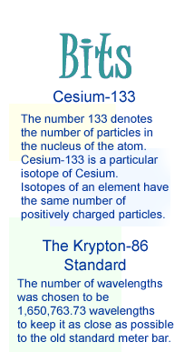
Physical Quantities
Units and Standards
Imagine a customer going to a grocery store and asking for 5 sugar or 1 milk! The clerk will be confused because the customer hasn't specified the units. A quantity is always specified with a unit such as pound or gallon. So in the above situation the customer could have asked for 5 pounds sugar and a gallon of milk.
Before specifying or using a unit it needs to be defined, for example before measuring length in feet you must know how much one foot is. Once defined a unit becomes a standard for all subsequent measurements.
A standard should be precise, invariable, and accessible. A widely used system of units is the International System of units, also called the SI system, which comprises seven base quantities (See Table 1). Each quantity has a unit for which a primary standard is carefully defined. For practical use secondary standards that are duplicates of the primary standard are used.
Table 1: The SI Base quantities
SL. No. | Base Quantity | Name of the Unit | Abbreviation Used
1. | Mass | Kilogram | kg
2. | Time | Second | s
3. | Length | Meter | m
4. | Temperature | Kelvin | K
5. | Current | Ampere | A
6. | Amount of substance | Mole | mol
7. | Luminous intensity | Candela | Cd
The Standard for Mass
The mass of a substance is the quantity of matter it contains. The standard mass of 1 kilogram is by common agreement the mass of a cylinder made of platinum - iridium maintained by the International Bureau of Weights and Measures near Paris.
The Standard for Time
The second is defined as the period in which there are a certain number (If you really want to know this number, it is 9,192,631,770!) of vibrations of a particular radiation emitted by a Cesium-133 atom.
The Standard for Length
The meter is defined as the distance that light travels in a vacuum in 1 / 299,792,458 of a second. Since the speed of light in vacuum is constant and can be calculated accurately as 299,792,458 meters per second, this value was fixed as the speed of light.

Measurement
The Importance of Measurement
Once units are defined, we can use them to measure quantities. Measurements are important to us in many ways; even in daily life we frequently measure quantities. Here are some examples from daily life where we measure quantities:
- Measuring body temperature
- Checking blood pressure
- Checking the pressure inside your car tires
- Monitoring the body weight to analyze the effectiveness of a new diet and exercise regimen
- Purchasing goods on the basis of their weights or volumes
- Measuring the distance traveled by a car
Measurement is central to physics because any new theory that is proposed must be tested by experiment, which requires careful measurements.
Conversion of Units
Often we require converting a quantity from one unit to another unit. Look at the examples given below.
Example 1.1:
A bus is traveling at 10 meters per second (m/s). What is its speed in feet per second?
Solution:
We convert meters (m) into feet (ft).
1 m = 3.28 ft.
Therefore
10 m/s = 10 x (1 meter / 1 second)
= 10 x (3.28 feet / 1 second)
= 32.8 ft/s
Notice that 'feet per second' is generally written as ft/s.

Example 1.2:
Convert 50 miles per hour into meters per second.
Solution:
To solve this problem we need to convert miles (mi) into meters and hours into seconds.
1 mi = 1.61 kilometers (km)
1 km = 1000 m
Therefore:
1 mi = 1.61 x 1000 m
= 1610 m
1 hour (hr) = 60 minutes (min)
1 min = 60 s
Therefore:
1 hr = 60 min
= 60 x 1 min
= 60 x 60 s
= 3600 s
So we can write
50 mi/hr = 50 x (1 mi / 1hr)
= 50 x (1610 m / 3600 s)
= 50 x 1610 / 3600 m/s
= 22.4 m/s
Example 1.3:
The speed of light in SI units is 3 x 10⁸ m/s. Express it in mi/s.
Solution:
1 mi = 1610 m. Therefore 1 m = 1/1610 mi.
3 x 10⁸ m/s = 3 x 10⁸ x (1 m /1 s)
= 3 x 10⁸ x (1/1610 mi / 1 s)
= 3 x 10⁸ x (1/1610) mi/s
= (3,000/1610) x 10⁵ mi/s
= 1.86 x 10⁵ mi/s.

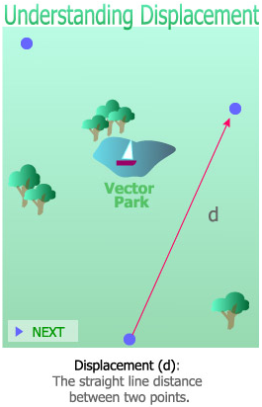
Vectors
Scalars and Vectors
When you measure quantities, some quantities can be described by just specifying their magnitude. For example if you want to describe how heavy a box is, you'll simply say that its mass is 4 kg. Such quantities are called scalar quantities; other examples of scalars quantities are area, volume, and temperature.
However there are other quantities for which you need to specify the direction in addition to magnitude. For example to describe the displacement of an object you say that the object is displaced by 3 m in the northeast direction. Such quantities are called vector quantities; other examples of vector quantities are force, velocity, and acceleration.
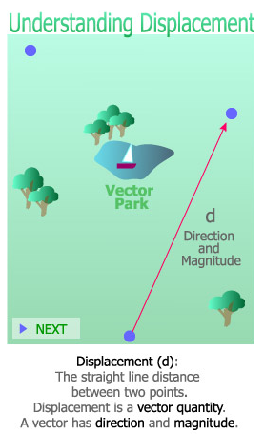
In this course whenever we define a new quantity, we'll ask ourselves whether the quantity is a scalar or a vector. Classifying quantities as vectors and scalars will help you understand them better.
The Addition of Vectors
Adding vectors is not as simple as adding scalars. To add two scalar quantities you just need to add their magnitude. For example the total mass of two objects with masses 2 kg and 3 kg is 2 kg + 3 kg = 5 kg.
To add two vectors the direction of the quantities has to be taken into account in addition to their magnitude. For example if you apply two forces on a body, one of 2 N and another of 3 N, the resultant force depends on the direction of the two forces.
The addition of vectors is done by the triangle rule of addition. This rule will be clear when you read the following examples.

Example 1.4:
Continuing with our example let's say that the 2 N force points to the North and the 3 N force to the East. What is the resultant force?
Solution:
We draw an arrow of length 2 units pointing to the North to represent the 2 N force. To add the 3 N force with the 2 N force we draw an arrow starting from the head of the first arrow, pointing to the East. The length of this line is 3 units. The resultant of these two vectors is the arrow joining the tail of the first vector with the head of the second vector as shown in the figure.
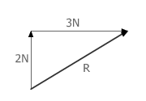
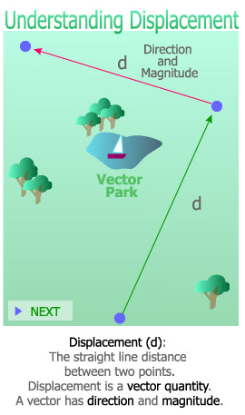
Now you know why this method of addition is called the triangle rule - the three forces form the three sides of a triangle.

Components of a Vector
Just as two vectors can be added up by the triangle rule, it is possible to break up a vector into two component vectors. This helps determine the effect of a quantity in a particular direction.
Of special interest are components that are perpendicular to each other. Let there be a vector A and let's draw X and Y coordinate axes (Vectors are denoted in bold font and scalars in normal font). Then you can draw two components of vector A, one parallel to the X-axis and the other parallel to the Y-axis. As it can be seen, the two components add up to vector A.
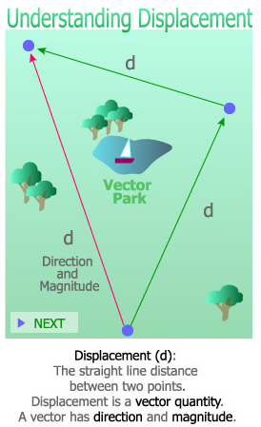
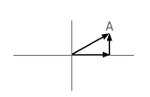
To replace a vector with its component vectors you need to find the magnitude and direction of the components. Let's see how to find the components of vector A, parallel to the coordinate axes. Choose the positive direction of the X-axis as pointing to the right and the positive direction of the Y-axis as pointing upward.
- When vector A is along the positive X direction, the X-component is vector A itself and the Y-component is zero. This is because a vector cannot have a component perpendicular to itself.

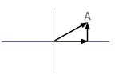
- When A is parallel to the Y-axis, the X component is zero and the Y component is the vector itself.
- When A makes an obtuse angle (more than 90°) with the positive X-axis, the component points in the negative X-axis direction. The Y component may be again positive or negative depending on the direction in which the vector is pointing.

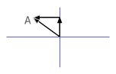

Kinematics

Kinematics is the study of the relationship between the position, velocity, and acceleration of an object. Kinematics is concerned with the motion of an object, and not with the forces that cause this motion. The relation between force and motion will be covered later under dynamics.
There are various quantities that describe the motion of an object; the prime ones being displacement, velocity, and acceleration. Let's begin our study on kinematics by first looking at displacement.
Displacement
Displacement is the change in the position of an object, and it is a vector quantity. Consider an example of displacement. Sally walks every day from home to her office, which is at a distance of 2 km. Sally actually walks more than 2 km to reach her office because there's no straight road connecting her home to the office. Also she does not take the same route everyday. But her initial and final points are the same. To describe her position at the two points, an arrow OA can be drawn from the initial point to the final point. The arrow represents a vector quantity because it has a magnitude, which is at a distance of 2 km, and its direction is from Sally's house to her work place. This vector is called the displacement vector.
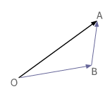

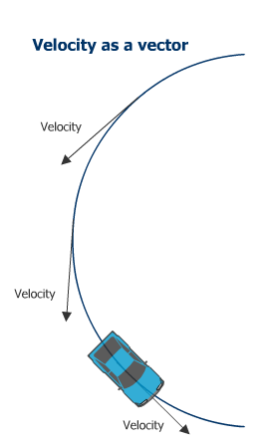
Velocity
Velocity is defined as the rate at which the position of an object changes with respect to time. Velocity is different from speed; let's see how. Speed does not take into account the direction of an object and therefore is a scalar quantity. The speedometer of a car measures speed; it does not give the direction of motion.
Velocity is a vector that points in the direction in which a car is traveling at any instant. If the car is traveling in a curved path, its velocity points in the direction of the tangent to the curve. The tangent at a point on the curve is a line that just touches the curve.
Acceleration
Acceleration is the rate at which velocity changes. Acceleration is a vector and has a magnitude and a direction. If the velocity is constant in both magnitude and direction, acceleration is zero; but, if either the magnitude or direction of velocity changes, there is acceleration.
Unit of Acceleration
Acceleration is the change of velocity per unit time. Therefore its unit is the unit of velocity divided by the unit of time.
So
The unit of acceleration = unit of velocity / unit of time
= (m/s) / s
= m/s²
An object can move in a straight path or a curved path; it can also move in the horizontal or vertical direction. Let's study about each type of motion.
Motion Along a Straight Path
A particle may sometimes move along a straight path. Examples of straight-line motion are:
- An object thrown vertically upward
- An object sliding or rolling straight down an incline
- A car traveling along a straight stretch of road
The simplest motion is when a particle moves in a straight path uniformly without any change in its speed. The distance it travels is given by Distance = speed x time or s = v x t, and the acceleration of the particle is zero.

Uniform Acceleration
We know that acceleration is a measure of how quickly the velocity of an object changes. If the velocity of an object changes at a constant rate, we say that the object is accelerating uniformly.
It is possible to calculate the velocity of an object if it is accelerating uniformly. The equation v = u + at can be used for this purpose.
In this equation
v is the velocity after t seconds,
u is the initial velocity, and
a is the acceleration.
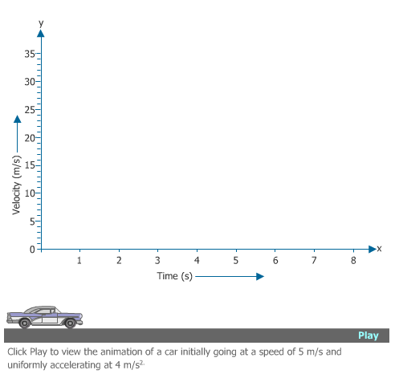
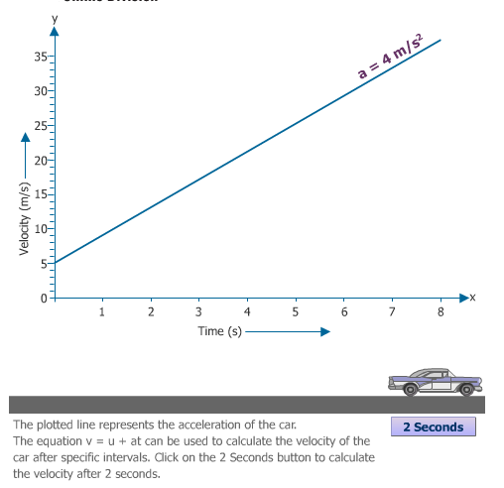
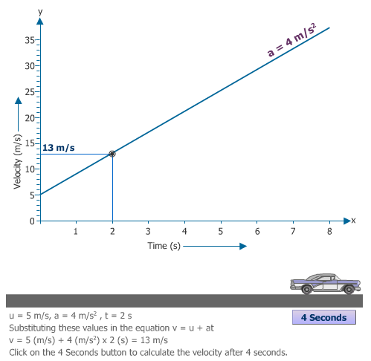
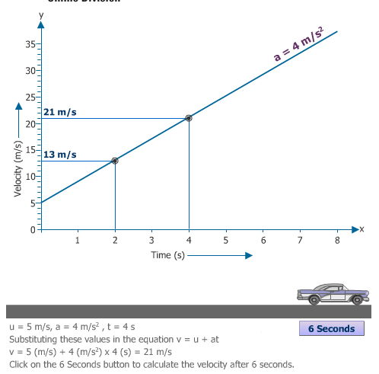
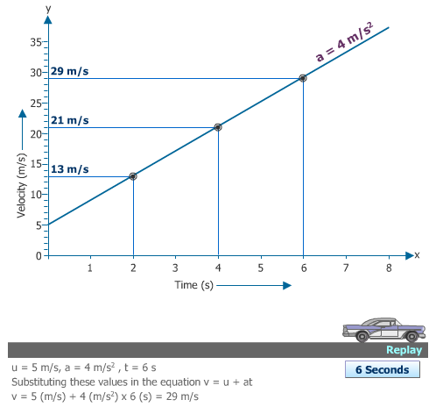

Deceleration
An object moving along a straight path with a constant acceleration can have acceleration either in the direction of motion or opposite to the direction of motion. Acceleration in a direction opposite to the direction of motion is also called deceleration. Deceleration happens when the final velocity of an object is lower than the initial velocity, for example when you apply brakes to stop a moving car.
Example 1.5:
If the car is traveling with a speed of 20 m/s and brakes are applied so that the acceleration is now in a direction opposite to that of the velocity and has a magnitude of 5 m/s², how long will it take to stop the car?
Solution:
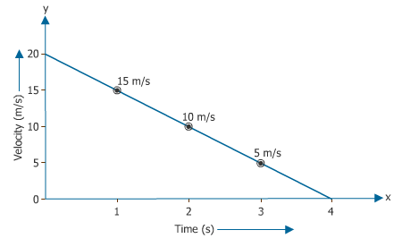
We can obtain result using the formula v = u + a t.
Here
Initial velocity, u = 20 m/s,
Final velocity, v = 0 at the end of time t,
And acceleration, a = - 5 m/s². Acceleration is negative because it is reducing the velocity. We can find the time t as follows:
0 m/s = 20 m/s - (5 m/s²) (t s)
or t = 4 s.

Finding the Distance Traveled
How do you find the distance that the car travels when it is accelerating? When velocity is constant, the distance traveled is velocity x time.
When the car is accelerating, the velocity of the car is continuously changing and you cannot use this formula. Instead you can take the average of the velocities at the beginning and at the end. This average velocity is (u + v) / 2. Substitute this expression for the velocity, and obtain the distance as d = (1/2) (u + v) t. Let's look at an example of calculating distance using this equation.
Example 1.6:
A car accelerates from rest and reaches the speed of 12 m/s in 3 s. what is the distance traveled by the car?
Solution:
Here
u = 0 m/s,
v = 12 m/s, and
t = 3 s.
So the distance traveled is:
d = (1/2) x (0 m/s + 12 m/s) x (3 s)
= 18 m
Example 1.7
If a car is traveling with a speed of 20 m/s and brakes are applied so that the car stops after 4 seconds, how far will the car travel before coming to a stop?
Solution:
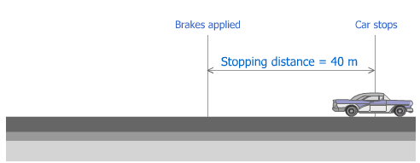
The animation shows the car stopping after 40 m. But how did we get this distance? The distance can be found by using the equation d = (1/2) (u + v) t as shown below.
Here
u = 20 m/s,
v = 0, and
t = 4 s.
Substituting the values in the equation d = (1/2) (u + v) t.
d = (1/2) x (20 m/s+ 0 m/s) x (4 s)
= 40 m
The car will stop after traveling a distance of 40 m.

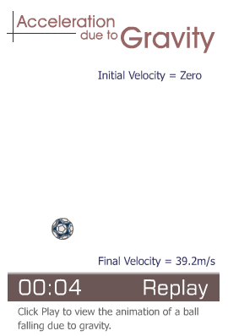
Vertical Motion in a Straight Line
Another example of motion with uniform acceleration is the motion of bodies in free fall or when they are thrown vertically upwards.
Acceleration in the case of vertical motion of objects is because of gravitational force, and it's called acceleration due to gravity, denoted by 'g'. It's the same for all bodies, and experiments show that g = 9.8 m/s² pointing in the downward direction.
The ball in the animation falls from rest and takes 4 seconds to reach the ground. During this time its speed increases from zero to 39.2 m/s. The increase in speed is because of the acceleration due to gravity and it can be mathematically calculated by the equation v = u + gt. Notice that in this equation acceleration a is replaced by g.

Motion Along a Curved Path
Let's now look into the motion of an object in a curved path, which is the most general case of an object in motion. For simplicity's sake we consider the motion of an object only in a single plane. An object moving along a curve always has acceleration because the velocity of the particle changes in direction even if it is traveling at a constant speed.
At any given instant the velocity of the particle is along the tangent to the curve (The tangent at a point to a curve is a line that touches the curve at that point and nowhere else). A roller coaster is an example of a particle moving in a curved path. Even if the roller coaster is moving with constant speed, its velocity is changing in direction; and therefore, it is accelerating. The acceleration is directed perpendicular to the tangent towards the concave side of the curve. If the path is a circle of radius r, the acceleration is towards the center of the circle with a magnitude v²/R .
Example 1.12:
As part of her training an Astronaut is whirled in a circle of radius 10 m with a constant speed of 20 m/s. What is her acceleration in multiples of g? Assume g = 10 m/s².
Solution:
The acceleration is towards the center of the circle (centripetal acceleration). It has a magnitude of v²/R
= (20 m/s)² / 10 m
= 400 m²/s² / 10 m
= 40 m/s².
1 g is the acceleration due to gravity that is approximately 10 m/s².
So 40 m/s² is about 4 g.

Weekly Summary
This brings us to the end of the first week of the course. The lectures covered basic concepts of science such as units, standards, and importance of measurements. You learned to classify quantities as vectors and scalars. The week also covered the concepts of kinematics, which explains the motion of objects in straight and curved paths. In the lecture on kinematics you learned about displacement, velocity, and acceleration.
Using the navigation on the left, please proceed to the next page to complete this week's assignments before proceeding to the next course lecture week.
Assignment 01 – Bio
Assignment 2: Discussion Questions
By Friday, November 13, 2009 respond to the discussion questions assigned to you by the facilitator. Submit your responses to the appropriate Discussion Area. Start reviewing and responding to your classmates as early in the week as possible. You can ask technical questions or respond generally to the overall experience. Be sure to be honest, clear, and concise. Always use constructive language, even in criticism, to work toward the goal of positive progress.
Grading Criteria | Maximum Points
Correct spelling and grammar. | 4
Well-formed conclusions. | 12
Participation and feedback in discussion. | 8
Total: | 24
For assistance with any problems you may have when completing this assignment—OR—to offer your assistance to classmates, please use the Problems and Solutions Discussion area located through the left side navigation link.
Q1 - Explain how force is a vector and not a scalar. Support your answers with appropriate examples.
Q2 - A car starts from a point and returns to the same point after 100 seconds. During this time the car traveled at an average speed of 10 m/s. What is its displacement? What is its average velocity? Explain your answers using a sketch if needed.
Choose either question one or two and answer that question to the best of your ability.
- Explain how force is a vector and not a scalar. Support your answers with appropriate examples.
Assignment 3: Conversion of Units
By Monday, November 16, 2009 complete the following exercise on conversions, and post your conclusions to the appropriate Discussion Area.
Grading Criteria | Maximum Points
Correct conversion. | 8
Total: | 8
For assistance with any problems you may have when completing this assignment—OR—to offer your assistance to classmates, please use the Problems and Solutions Discussion area located through the left side navigation link.
Q1 - Convert a speed of 25 meters per second to feet per second.
Q2 - A snail moves 12 inches in a day. How many millimeters does it move in an hour?

